Henry="""Emma Watson called you!

Can you come soon?"""

Henry[3]='5'

print(len(Henry))

leads to type error=item cannot be assigned.

Operations in string:

1.Concatination:

Henry="""Emma Watson called you!"""

peter="Can you come soon?"

print(Henry+peter)

o/p:Emma Watson called you!Can you come soon?

2.Repitation:

Henry="""Emma Watson called you!"""

peter="Can you come soon?"

print((Henry+peter)*8)

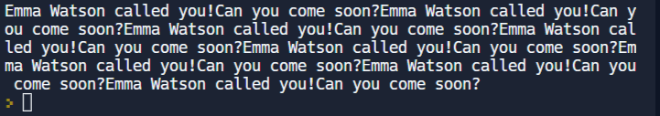

3.Membership:

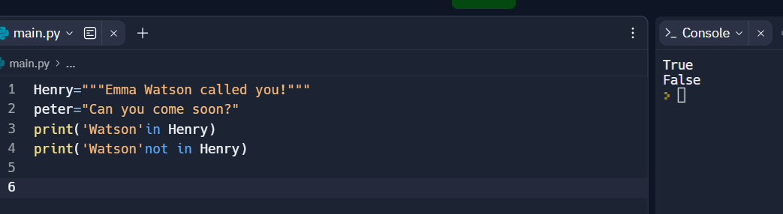

4.Slicing:

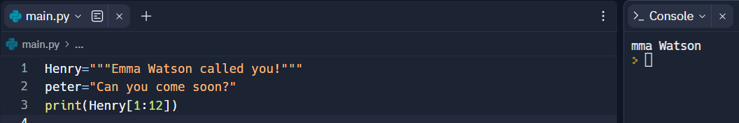

5.Traversing(using loops for and while):



